## Merchant Name: ENFOS Implementation POC: Royce *(IM to fill)* CX POC: *[IMP to Add]*

### 

### 

| Notes Sections   *(AE to fill if they have, Implementation to be completion DRI on handoff)*   * Info on how merchant bills   Billing model: - high ACV, multiyear, paid upfront or annual billing - Historically: Onboarding  - defined schedules  - based on completion - Software Flat fee - Future state: modules  - AP portals for some clients **They will scope this with us later down the line- feel free to loop me in here if/when we need to revisit**  Process:Deal closes→ Alex K needs to ping Roger (for confirmation to kick off invoicing) → Alex K gets PO → manually creates invoices in QBO → manual chasing/follow up  Manual spreadsheet to keep track of ARR  - cannot split by product   Moving from cash basis → GAAP compliant accrual accounting  - 31 logos today → 40 by EOY → 50+ by end of 2026  1) What is the merchant temperament?  Alex K- the one doing the invoicing, very nice Alex B- Chief of Staff/CRO- running the eval, straight forward and easy to work with Sherry- EA + doing some of the billing today, nitpicky and detail oriented  George- CS- very nice. cares about renewals  Alexa- Implementation- very nice. Cares about single source of truth  3) What are the Tabs features that the key POC cares about? |
| --- |

### Billing model *(Entire Section: Implementation to fill section)*

* Are there unique things about the customer creation process for this merchant?
* Information on how merchant bills
* How contract is broken up
* One off things to know about the merchant

### Contract Processing Steps *(Entire Section: Implementation/Success to fill Post-Go Live)*

1. **Steps to process**

Where your information is coming from:

* Billing Terms come from Order Forms or Sales Orders
  + If it is a sales order, it will say so *clearly* on the contract
  + if you're processing a sales order or order form, you should double check the MSA that corresponds with it for the net terms
* **Net Terms** come from the MSA
  + You can leave the MSA as processed without BT but these net terms should be reflected on the associated Order Form or Sales Order
  + **Do not** process any BT listed in the MSA
* **DO NOT** process Purchase Orders (POs). This is the information you should take from the PO:
  + the PO number (must be inputted as an additional field on the invoices of the corresponding contract)
    - Please make sure that you are adding the PO to the correct invoices!!
  + the shipping and billing address should be added to the customer
    - The billing and shipping address for the contract should correspond to the associated PO
  + Some contracts/order forms do not have an associated PO

Contracts themselves are relatively straightforward - process according to what the contract says.

* **Service Start Date:** use the listed start date
  + Default to last signature date if nothing is stated
* **Month of Service:** use the number of months in the term
  + Default to 12 months if nothing is stated
* **Item Name**: Use the name of the product
* **Item Description**: include the description of the products/services included. Example below - parts circled in pink should be in the description:



* **Quantity**: use stated quantity
  + Default to 1 if nothing is stated
* **Total Price**: Use the listed price
  + Check for special terms and conditions or payment terms or additional rules for specific invoicing cadences
* **Billing Start Date**: match service start date unless a different invoicing cadence is stated
* **Number of periods:** infer from frequency and months of service
* **Frequency:** based on the payment schedule and term
  + If paid annually, YEAR
  + If monthly, MONTH
* **Net Terms**: check the associated MSA for that customer & order form for the net terms
  + The PO and order forms may list different net terms, but you should **always** use the net terms in the MSA
* **Billing Timing**
  + **Bill in advance, due start of period**
* **Integration Item**: refer to mapping here <https://docs.google.com/spreadsheets/d/17z0413nEs-2hZ6lcNQSeK5Yja8UlyyGwZyIlFgj7clQ/edit?gid=353851581#gid=353851581>
* **PO Number reminder!**
  + Remember to check for POs associated with that order form and add the PO number to each invoice

If the price of the product is different per year - create a separate revenue schedule for each year

* For example, the below should be 3 revenue schedules/billing terms:
  + Year 1 service start date 6/9/2025 for 12 months
  + Year 2 service start date 6/9/2026 for 12 months
  + Year 3 service start date 6/9/2027 for 12 months
  + Contractid b9fefb64-f717-41d4-b9ee-37253434654c

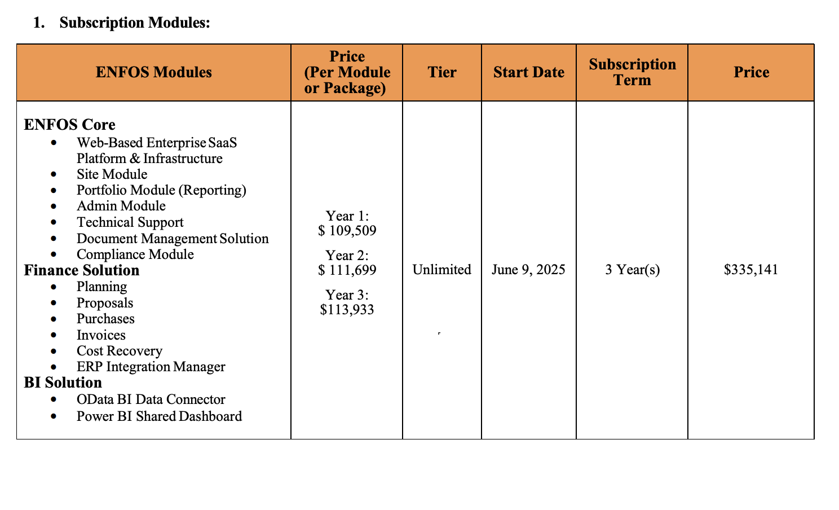

**Double check the following:**

 • Customer

 • Invoice date

 • Terms

 • Due date

 • Billing to

 • Shipping to

 • PO number

 • Product

 • Period

 • Amount

1. Anything to ignore in contracts?
2. Specifics processing things the merchant has requested that may differ by contract (e.g. always back-date invoice date to final day of the month)
3. Default Service Term
   1. If None Listed, Ops Default is 1 Year
4. Default Net Payment Terms
   1. If None, Ops Default is 0
5. Default Billing Frequency
   1. If None Listed, Ops Default is Monthly
6. How do we handle taxes as a line item?
   1. If None Listed, Ops Default is every tax line item becomes a BT

### Events Processing (if necessary) *(Entire Section: Implementation/Success to fill Post-Go Live)*

* Any important information on events billing

Integration Items Processing (if necessary)  
*(Entire Section: Implementation/Success to fill Post-Go Live)*

* What are the instructions for assigning integration items?
* Example: All Statsig integrations items should be labeled as “Sales”
* Example: All “Pinata” integration items should be labeled as “Software Subscription Bundle” unless otherwise noted by Merchant

Post Processing Communications (if necessary)  
*(Entire Section: Implementation/Success to fill Post-Go Live)*

* Does the Ops Team need to notify anyone on the team re: completion of processing batches in Implementation or Active phase?
* Who needs to be notified and when?
  + Example:
    - Who: Customer Success [Azmat Aziz] needs to be notified
    - Where: Messari internal merchant channel
    - When: contracts are processed [Merchant Phase: Active]

### Customer Information *(Entire Section: Implementation/Success to fill Post-Go Live)*

* Any important information on specifics customers of this merchant
  + Special memo’s certain invoices require
  + Invoice changes due to merchant/customer relationship

### Feature Requests *(AE to fill for all requests prior to Imp handoff, Imp to fill prior to go-live/Success to fill to fill Post-Go Live)*

* FR 1
  + CARR

### Merchant Calls *(AE to fill for all videos prior to Imp involvement, Imp to fill prior to go-live/Success to fill to fill Post-Go Live)*

* .Intro <https://us-56595.app.gong.io/call?id=9133609961427745123&account-id=4661979429957038267>
* .Custom demo <https://us-56595.app.gong.io/call?id=5314733701650479051&account-id=4661979429957038267>
* .Partnerships <https://us-56595.app.gong.io/call?id=3826951672038898896&account-id=4661979429957038267>